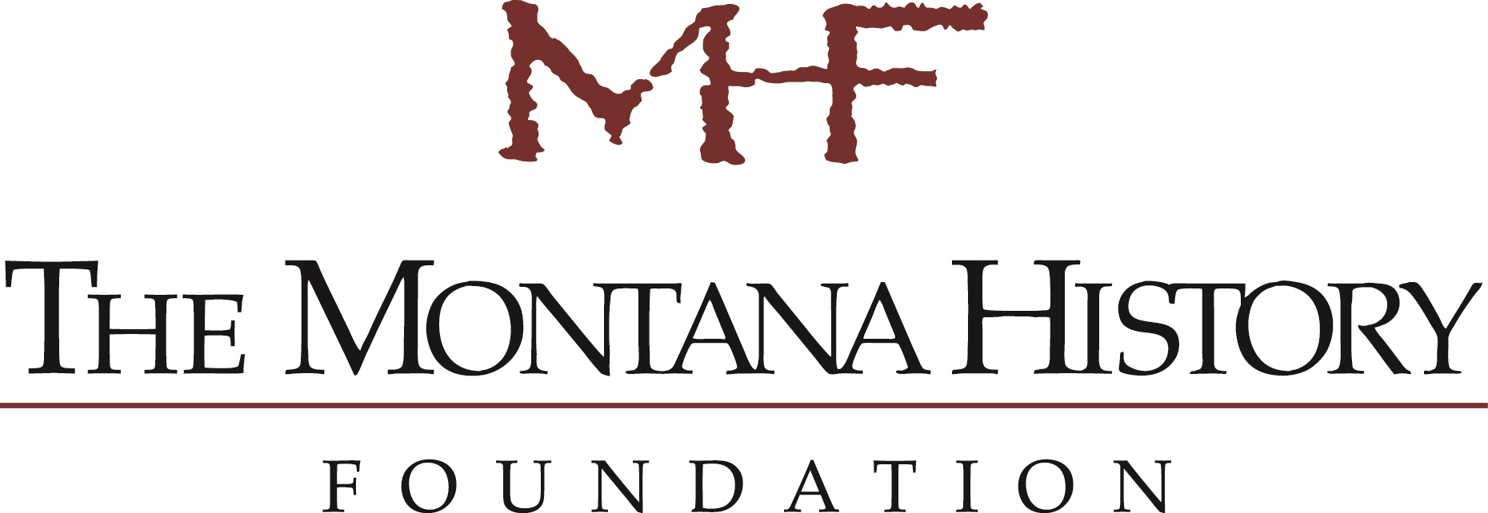

WHERE TO FIND FUNDING & PARTNERSHIPS FOR HISTORY AND PRESERVATION PROJECTS

For live links, please view this document at www.mthistory.org/grant-resources

Please note that this list is not meant to be inclusive and should be used as a starter tool only. All represented data is subject to change.

State and Local Funders
Funder/Partner | Grant | Website | Purpose | Approximate Due Date | Funding Range
Blue Cross Blue Shield |  | https://www.bcbsmt.com/company-info/community-involvement/community-giving | Supports program-focused areas or provides operating support. Support organizations that align with mission to promote health, wellness, and human services in the communities BCBS serves. | Blue Cross Blue Shield
BNSF Railway Foundation |  | http://www.bnsffoundation.org/ | Supports and improves the general welfare and quality of life in the communities served by BNSF. | ongoing
Browning-Kimball Foundation |  | https://fmiokc.com/clients/browning-kimball/ | Committed to improving the quality of life through support of youth and families, health with an emphasis on prevention, arts and humanities, and sustainable agriculture. Preference given to organizations in central Montana. | LOI due by March 1
Dennis and Phyllis Washington Foundation |  | https://www.dpwfoundation.org/grants/ | Funding for organizations that support education, health and human services, arts and culture, and community service. | Ongoing
Funder/Partner | Grant | Website | Purpose | Approximate Due Date | Funding Range
Humanities Montana | Regular and opportunity grants, research fellowships, film and video grants | http://www.humanitiesmontana.org/ | Encourage proposals that engage Montanans in meaningful discussion about the human condition, strengthen cooperative relationships among communities and cultural organizations (museums, libraries, schools, tribal organizations, etc.), and enrich civic discourse among the state’s diverse cultures and across its geographical distances.
Jerry Metcalf Foundation |  | http://www.jerrymetcalfmontana.org/grantguidelines.html | Supports the visual, performing, and literary arts; historical research and preservation; environmental research and conservation; and education and community health. | LOI and application due March 15 | $1,000-$15,000
Montana Arts Council |  | https://art.mt.gov/grants_awards_comm_home | Develop the creative potential of all Montanans, advance education, spur economic vibrancy and revitalize communities through involvement in the arts.
Montana Community Foundation |  | https://mtcf.org/grants/about-grants | Funds fields of interest such as human services, affordable housing, public education, or the performing arts.
Montana Department of Commerce | Montana Community Development Block Grant Program | https://comdev.mt.gov/Programs-and-Boards/Community-Development-Block-Grant-Program/Economic-Development | Designed to stimulate economic development activity by assisting Montana’s private sector to create or retain jobs for low- to moderate-income Montanans. | Ongoing
Montana Dept. of Commerce | The Montana Main Street Program | https://comdev.mt.gov/Programs-and-Boards/Montana-Main-Street-Program/ | Helps communities strengthen and preserve their historic downtown commercial districts by focusing on economic development, urban revitalization, and historic preservation through long-range planning, organization, design, and promotion. | December 9 | Max of $10,000
MDU Resources Foundation |  | https://www.mdu.com/about-us/community/ | Grants supporting arts, culture, education, health and community development in communities where MDU Resources operates. | October 1
Funder/Partner | Grant | Website | Purpose | Approximate Due Date | Funding Range
MJ Murdock Charitable Trust |  | https://murdocktrust.org/grant-opportunities/ | Funds strategic projects and initiatives in a five-state region which includes Montana. | LOI
Montana History Foundation | General Grants Program | https://www.mthistory.org/grants/ | Offers grants for historic preservation, oral history, artifact conservation, document digitization, museum exhibits, and more. | January | $500-$10,000
Montana History Foundation | History Emergencies! | Call for further details: 406-449-3770 | Provides funding to restore, conserve, or repair historic resources that are a direct benefit to the community and in imminent danger. | Ongoing | $1,000-$7,500
Montana Historical Society | Community Preservation and Certified Local Government Program | https://mhs.mt.gov/Shpo/index5 | Certify local government with historic preservation programs, provide technical preservation assistance, and annually dedicate 10% of federal funding to cities, towns, and counties that commit themselves to preserving their heritage under the program. |  | $1,000-$5,000
Montana State Library | Montana Memory Project | http://docs.msl.mt.gov/mmpweb/webpagedocs/brochure3.pdf | Grant funding available to interested applicants. All Montana libraries, museums, archives, and schools are encouraged to become contributors of the Montana Memory Project. | Montana State Library
Montana Office of Tourism | Tourism Grant Program | https://brand.mt.gov/Programs/Office-Of-Tourism/Tourism-Grant-Program | Awards funds to projects that strengthen Montana’s economy through the development and enhancement of the State’s tourism and recreation industry. | September
Northwestern Energy Charitable Giving Program | Community Works | https://www.northwesternenergy.com/in-your-community/charitable-programs# | Supports education, health, and human services, civic and community, culture and arts, and resource conservation in communities they serve. | Northwestern Energy Charitable Giving Program
Preserve Montana | Various Programs | http://www.preservemontana.org/restoration-training | Assistance to communities and owners of historic properties.
Steele-Reese Foundation | Idaho and Montana Grant Program | https://steele-reese.org/ | Supports rural education, rural human/social services, rural conservation and preservation, rural health, and rural arts and humanities programs. | LOI | $5,000-$50,000

Federal Grant Makers

Funder/Partner | Grant | Website | Purpose | Approximate Due Date | Funding Range
Department of Agriculture -Rural Development (USDA) | Various | https://www.rd.usda.gov/programs-services/all-programs | Offers programs in the area of housing and rural community development that can be of assistance to preservation efforts.
Economic Development Administration | Various | https://www.eda.gov/funding-opportunities/ | Promotes innovation and competitiveness, preparing American regions for growth and success in the worldwide economy. | various
Institute for Museum and Library Services | Various | https://www.imls.gov/ | Primary source of federal support for the nation’s libraries and museums. Aims to advance, support, and empower America's museums, libraries, and related organizations. | various
National Archives | Various | https://www.archives.gov/nhprc/announcement | Promotes the preservation and use of America’s documentary heritage essential to understanding our democracy, history and culture | various
National Endowment for the Arts | Various | https://www.arts.gov/grants | Funds, promotes, and strengthens the creative capacity of our communities by providing all Americans with diverse opportunities for arts participation. | various
National Endowment for the Humanities | Various | https://www.neh.gov/grants | Supports research, education, preservation, and public programs in the humanities. | various
National Park Service | Historic Preservation grants | https://www.nps.gov/subjects/historicpreservation/fund.htm | Preservation projects include a wide range of activities from bricks-and-mortar rehabilitation to neighborhood surveys and documentation efforts. | various
National Trust for Historic Preservation | Various | https://savingplaces.org/ | Protects significant places representing our diverse cultural experience by taking direct action and inspiring broad public support. | various

